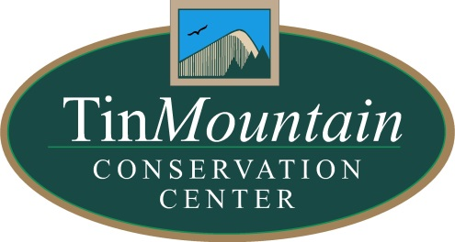
PRESS RELEASE: For Immediate release
Contact: Dawson Winch, Tin Mountain
Email: dwinch@tinmountain.org
Phone: 603-447-6991
April 12, 2021
Nature Programs and Field Trips
Tin Mountain Conservation Center

Online Program
Spring Birds & Water Fowl
Thursday, April 22, 7pm
Join us for a discussion of birds that we can expect to see during our upcoming Ducks and Donuts field trip. Learn about common waterfowl species and their unique field identification markings, along with some facts about the ecology of these charismatic species. We’ll also take some time to talk about other early spring birds in the area.
Visit www.tinmountain.org for link.

Field Program
Ducks & Donuts
Saturday, April 24 8:30-11:30am
The streams and ponds are opening up and ducks are returning. We’ll explore the old course of the Saco River and other open water in search of wood ducks, hooded mergansers, common golden eyes, and other early migrants. Bring binoculars and we’ll bring the donuts! Cost: $5/person
Space is limited; reservations required. Click here to register online or call 603-447-6991.
Cost: $5/person

Online Program
Identifying Spring Warblers
Thursday, April 29, 7pm
Lifelong birder Will Broussard will help us prepare for the upcoming warbler season with a review of the common and not-so-common warblers of the Mount Washington Valley. All aspects of identification will be examined including field marks, song, and habitat.
Sponsored in part by the Friends of the Whitney Center
Visit www.tinmountain.org for link.

