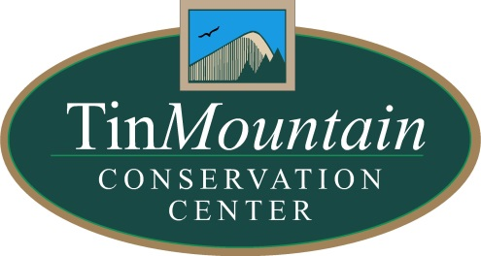
PRESS RELEASE: For Immediate release
Contact: Dawson Winch, Tin Mountain
Email: dwinch@tinmountain.org
Phone: 603-447-6991
June 4, 2020
Tin Mountain Conservation Center Welcomes
New Interns and New Board Members

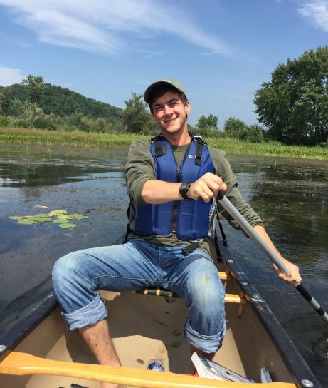
[June 6, 2020 ALBANY, NH] Despite the many changes we’ve all experienced in the past 12 weeks, the life cycle of nature and seasons continue. The birds have arrived, the bulbs have bloomed, the black flies have arrived and Memorial Day has come and gone meaning summer is here. Summer signals many things, not the least of which is the arrival of the new research interns at Tin Mountain Conservation Center in Albany, NH. Tin Mountain’s intern season has not escaped unscathed by the pandemic. Three interns will be working on the in Mountain research projects this summer due to housing and social distancing concerns. Though the number is smaller the talent and skill that these interns possess is impressive so we wanted to introduce them to you.
Hi! My name is Connor Quinn and I’m an intern for the Brook Trout Habitat Restoration project for the summer 2020 season. I was born and raised in central Massachusetts and I come to Tin Mountain from beautiful Craftsbury Common, Vermont where I’ve lived since 2018. I’m currently a senior pursuing a degree in ecology and natural resources at Sterling College, a small school that’s focused on ecological thinking and action, just like I am. My interests in the outdoors and natural sciences stem from my pursuit in developing a strong sense of place and understanding in the natural communities where I’ve grown up in the northeast. The brook trout project stood out to me because I recognize the importance of improving habitat for wildlife, as well as understanding how and why restoration projects work. I also just really like spending time in and around water! Aside from my primary interest in stream ecosystems, I also like to explore and learn about nonvascular plants like mosses and liverworts, pollination ecology, and green stormwater infrastructure.
Some other things I’m easy to talk about include anything related to agriculture, backcountry camping, cooking, and my lifelong endeavour to find the world's best ice cream. Ask me about my record for the amount of Ben and Jerry’s consumed in an afternoon!

Hi! I’m Sam Mason, a rising senior at Hobart and William Smith Colleges in Geneva, New York, and I’m excited to join the Tin Mountain team for the summer as the Scientific Literacy intern. This is a new intern position for Tin Mountain. As the Scientific Literacy intern, I’ll be accompanying both the avian program team and the trout stream restoration program in the field while simultaneously taking photos, shooting video and writing articles for the Tin Mountain social platforms. I’m looking forward to creating a variety of content that highlights the conservation work and research programs that Tin Mountain conducts for the general public. In other words, I’m ‘translating’ the science text into content that effectively explains the sometimes complex scientific findings associated with these two projects.
Although I’m from the South Shore of Massachusetts, I spend most of my time in Jackson, New Hampshire enjoying the White Mountains. I’m an avid fly fisherman, and can often be found on the Wildcat or Androscoggin Rivers chasing Brook and Rainbow trout. When not on the water, I enjoy hiking and playing golf. As a former camper and then camp counselor at Tin Mountain, I am excited to once again be part of team and am looking forward to what the summer holds!

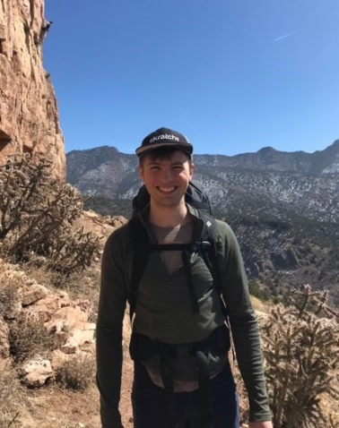
Hi! My name is Donovan Spaulding and I graduated from Saint Lawrence University in 2019 with a B.S. degree in Conservation Biology. This summer I’ll be an avian research intern at Tin Mountain Conservation Center this summer. Over the course of the summer, I’ll be studying the effect of timber harvesting on the presences of different bird species in forest stands.
In my spare time, I enjoy birding with friends and family throughout New England. I am an avid rock climber and enjoy the multiple crags located throughout the White Mountains. The Mount Washington Valley is home to many of my favorite flora and fauna, and I look forward to exploring new and different places during my time here at Tin Mountain Conservation Center.

Board of Trustee Changes
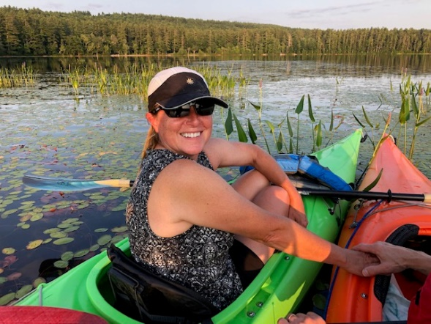
Like many organizations, Tin Mountain Conservation Center held its annual business meeting online and is hoping that everyone can gather sometime later this year for the social part of the annual meeting. This year, the board said goodbye to Jen Hohenboken who rolled off the board after serving 6 years. Tin Mountain Executive Director Lori Kinsey summed up Jen’s six years of service by saying, “No matter what we did, Jen always made us look better. From the gardens at the Nature Learning Center, to flowers at the First Season Dinner & Auction, to lavender scented towels at the Mt. Washington Century+ bike ride, Jen always went the extra mile, her talent, dedication and many contributions will be missed.”

Three new members joined the Tin Mountain Board of Trustees.
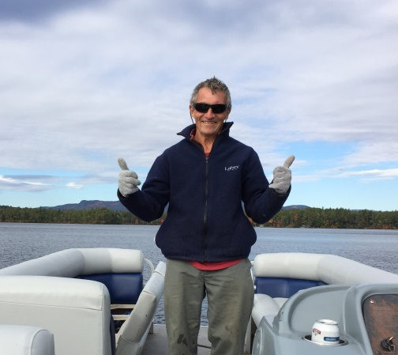
For many years Bill Petry has been involved in a variety of environmental conservation efforts in and around his homes in Florida and here on Conway Lake. While in NH, Bill is a volunteer for the Loon monitoring program and serves as the Membership Chair of the Conway Lake Conservation Association. He also coordinates efforts to monitor and eliminate invasive plants on Conway Lake. Bill’s interest in eliminating invasive species extends to the Institute for Regional Conservation in Delray Beach, Florida. In 2017 Bill received certification as a Florida Naturalist. Bill holds degrees from Tufts and Harvard and worked in Microwave technology in Massachusetts.

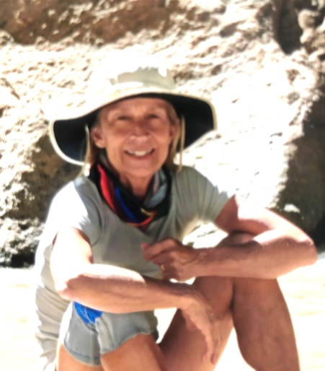
Susan Clark also joined the Tin Mountain Board of Trustees. Susan’s unique background includes experience teaching kindergarten as well as experience in both historical preservation and therapeutic horseback riding. She served as the secretary for both the Historic District Commission Board in Amherst, NH and the board of Questers, a national non-profit organization that brings historical and antiquity programs to elementary grade students. Through her therapeutic equestrian programs, Susan worked with differently abled adults and children including a program for wounded warriors. These programs enabled challenged individuals to experience the healing power of horses. In several of these roles she contributed her talent and expertise in development.
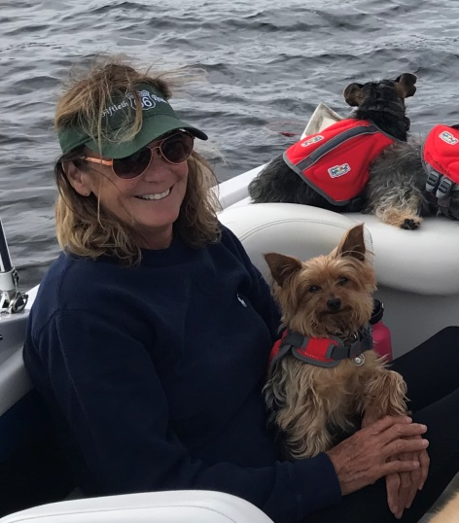
Nancy Devine brings over 35 years of experience in development and philanthropy to her role as a member of the Tin Mountain board of Trustees. Nancy’s long career in development, marketing and communications includes roles at the Community Foundation for Greater New Haven in CT, Africare in Washington, DC and Huggins Hospital Charitable Foundation in Wolfeboro, NH. Nancy has been a consultant with Tin Mountain and helped develop the Tin Mountain Conservation Center Legacy program for planned giving. Nancy has served as the North Country Board Chair for the New Hampshire Charitable Foundation, Board member of the NH Lakes Association and is also an Ambassador at Cranmore Mountain.

While the Nature Learning Center remains closed to the public due to the pandemic, the trails are open so come enjoy! Stay tuned to learn more about our online Nature Program Series. To become a member, get involved, and learn more about Tin Mountain’s Nature Programs, Eco-Forums, Camps and events visit www.tinmountain.org or contact us at info@tinmountain.org or call 603-447-6991.

###

