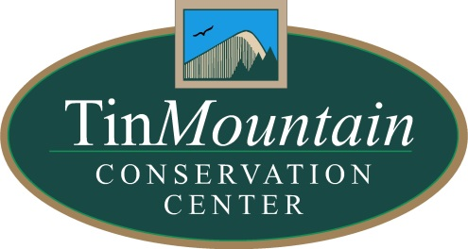
PRESS RELEASE: For Immediate release
Contact: Dawson Winch, Tin Mountain
Email: dwinch@tinmountain.org
Phone: 603-447-6991
April 27, 2020
Online Nature Programs from Tin Mountain Conservation Center
Daily Trivia: Sign up at info@tinmountain.org to receive the daily trivia email. The daily email also includes information on the weekly online Nature Programs.
VIRTUAL PROGRAM: Trout Stream Restoration
Thursday, April 30, 7pm

Streams and riparian areas are dynamic, and change dramatically over decades and centuries. Research in the last thirty years has shed light on the interconnected nature of streams and riparian areas, documenting that riparian zones are indeed an integral part of stream ecosystems. Much of that research has demonstrated the importance of wood in streams to fish habitat and nutrient cycling, and emerging information on the role of light on the productivity of stream ecosystems. Come learn about research from New Hampshire and beyond on fish habitat and instream wood, and what we may expect in our streams in the coming decades as forests age. As well as several stream restoration projects that use our knowledge of stream and riparian processes to help stream ecosystems become healthy again. Visit www.tinmountain.org closer to the date of the event for the link to the Zoom meeting or access through the daily trivia email.

Book Group Discussion: The Adventure Gap
Wednesday, May 6, 3pm

The book chronicles the first all-African American summit attempt on Denali, the highest point in North America. This book is part adventure story, part history, and part argument for the importance of inspiring future generations to value nature. White Birch Books has several copies of the book available, and are offering curbside pick-up to those interested. You can also order the book directly from their website.
Tin Mountain’s Environmental Group is sponsored in part by the Stephen & Tabitha King Foundation
Join the discussion via Zoom (even if you haven't finished the book!): Visit www.tinmountain.org closer to the date of the event for the link to the Zoom meeting or access through the daily trivia email.
Next Up: Silent Spring by Rachel Carson (June 3)

VIRTUAL PROGRAM: New England Wood Warbler ID
Thursday, May 7, 7pm

May is the peak of Spring Migration in Northern New England. Join Tin Mountain trustee and lifelong birder Will Broussard for a program that dives into the diversity of wood warblers winging their way into the Granite State and how to identify them by sight, sound and behavior. Tips and tricks for locating them in the field and attracting them to your yard will also be discussed. No prior birding experience is necessary! Visit www.tinmountain.org closer to the date of the event for the link to the Zoom meeting or access through the daily trivia email.

###

